PDF Studio - Code Source

1-PDF Studio - Ai Question - 1
# Source: Person Source: Provided by: [Data Path: Persons Table -> ID Column: 1, Name_En Column: Motasem Essam] Written by: [Data Path: Persons Table -> ID Column: 1, Name_En Column: Motasem Essam] on [6/12/2026]
- it has toolbar called home
- In home has selected file to choose file I want to open
- View can have multiple opened files like adobe acrobat
- add new option beside zoom is fit one full page
- Make the left/right arrow buttons actually flip pages:
- ◀ → previous page
- ▶ → next page
- Keyboard Left Arrow → previous page
- Keyboard Right Arrow → next page
- Page number stays synchronized.
- good make keyboard right arrow and left arrow flip pages next page and previous page
- when click ctrl + move scroll wheel make page zoom in or zoom out
- when click ctrl + w close current page
- add export in toolbar to convert pdf to images all pdf or part of it
- add split in toolbar
- add merge in toolbar
- make merge has two option
* merges pdf
* or images
- add compress button to reduce pdf size

2-PDF Studio - Ai Answer - 1
# Source: AI Source: Provided by: [Data Path: Persons Table -> ID Column: 1, Name_En Column: Motasem Essam] -> From: [ChatGPT] on [6/12/2026]
Project structure
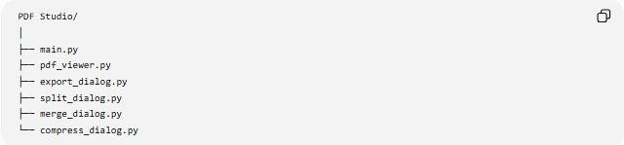
PDF Studio/
│
├── main.py
├── pdf_viewer.py
├── export_dialog.py
├── split_dialog.py
├── merge_dialog.py
└── compress_dialog.py

